**Amoeba Sisters Video Recap: *Classification***

|  |  |  |
| --- | --- | --- |
| 1. First things first! Some important vocabulary: compare and contrast a **prokaryote** cell with an **eukaryote** cell. | 2. Important vocabulary continued: label and *illustrate* an **autotroph** and a **heterotroph** organism. Underline the one that produces its own food. | 3. Important vocabulary continued: what is the difference between a **unicellular** organism and a **multicellular** organism? |
| 4. Classification is often changing! After introducing the domains, this video shows a 5 kingdom and 6 kingdom system. Why is classification subject to change? | 5. Complete the diagram below to show all taxonomic levels from most inclusive (top in diagram) to least inclusive (bottom in diagram). | |

What’s in a Name?

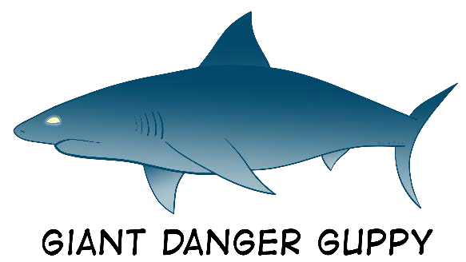

|  |  |
| --- | --- |
| 6. What is the benefit of a scientific name vs. a common name? | 7. The video explains the two parts of a scientific name in **binomial nomenclature**. Label the parts of this scientific name below and write in any general facts about scientific names that you recall from the video.  *Hydra vulgaris* |

Prokaryote Organisms



8. In the video, two different domains of prokaryotes were discussed. In a six kingdom system, these prokaryotes can also make up two of the six kingdoms. Describe these two separate prokaryote groups.

Eukaryote Organisms

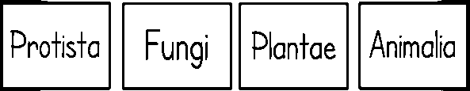

9. In the video, the domain Eukarya includes all eukaryote organisms. In a six kingdom system, these eukaryotes can make up four of the six kingdoms. Name these separate eukaryotic kingdoms and list descriptive words and examples for each. In your descriptions, use the bolded vocabulary words correctly from #1-3 on the previous page.